A000-Mex-Baja-Obsidian-Valle de Azufre

Case no. Baja

Obsidian from Valle de Azufre, Baja California  
  
  
Studies have identified at least eight locations in Baja California with geological deposits of obsidian that were exploited prehistorically (Figure 1). These include, from north to south, San Felipe, Arroyo Matomí, Puerto el Parral, Bahía San Luis Gonzaga, Isla Angel de la Guarda, Ensenada del Pescador, Valle de Azufre, and Punta Mangles (Banks 1971; Bouey 1984; Douglas 1981; Gutiérrez and Hyland 2002; Hyland 1997; Hyland and Gutiérrez 1995; Moore 2001; Ritter 1979; Ritter and Payen 1992; Shackley 1994, 1995, 1997, 1998a, 1998b, 2004a; Shackley et al. 1996; www.swxrflab.net).

Valle de Azufre contains notably high-quality obsidian that was intensively quarried prehistorically and dominated the source of obsidian throughout most of the Sierra San Francisco.

This specimen from the Valle de Azufre in the Sierra San Francisco is an example of a large obsidian “core” from which would have been made many projectile points and blades.

Figure 2 indicates the location of the source of this specimen (Valle de Azufre) and the large distances it was diffused probably by prehistoric Cochimi. Valle de Azufre obsidian has been found in the area east of Bahía de los Angeles (200 km from Valle de Azufre), at Laguna Manuela (160 km from Valle de Azufre), on Isla Cedros (250 km from Valle de Azufre), at Bahía Asunción (180 km from Valle de Azufre), at Bahía de la Concepción (120 km from Valle de Azufre), and at San Javier (210 km from Valle de Azufre), (Des Lauriers 2006; Shackley 1999, 2002, 2004a, 2004b; Shackley et al. 1996).

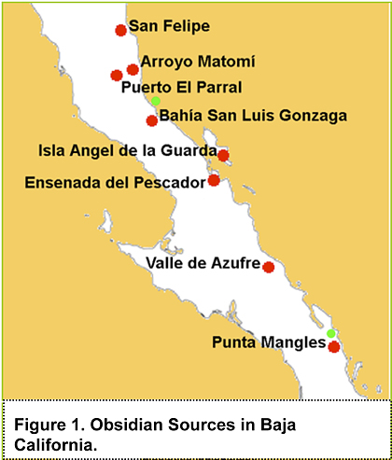 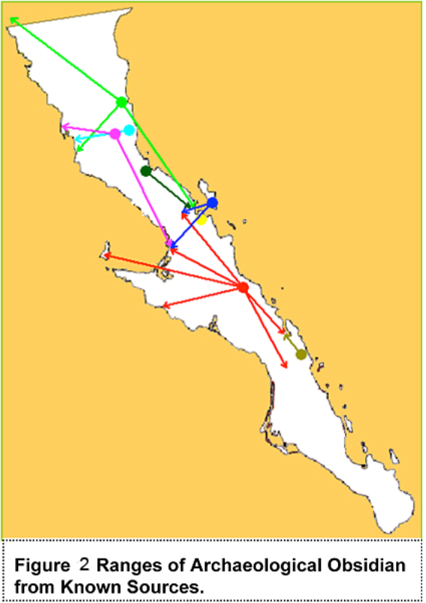

It has been speculated that in order for a prized good like obsidian to be transported by hunter-gatherers (without intercommunity exchange mechanisms like trade fairs) across distances on the order of 100 km or more, either prehistoric population densities had to be exceptionally low or the territoriality of communities had to be weak (cf. Kelly 1995:112-115). However, neither of these conditions prevailed in Baja California, judging from the ethnohistoric record. With more robust intercommuity mechanisms like seasonal trade fairs it is reasonable to attribute these to the diffusion of Valle de Azufre obsidian.

Grand Mural rock art styles and protocols such as the training of acolytes in the grammar of its art may be correlated with these obsidian studies: intercommunity exchange mechanisms of obsidian may have paralleled and even sustained the diffusion of both obsidian and Grand Mural rock art styles from the Valle de Azufre which was a major center of trade and exchange. This specimen may offer an insight into the origins and mechanisms of dispersal of the Grand Mural rock art styles and protocols.

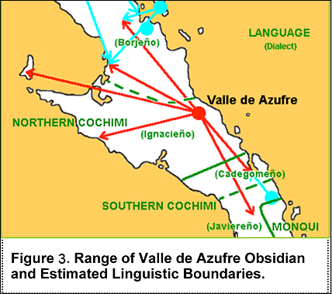

The cultural association of Valle de Azufre obsidian also strongly supports the connection of the Grand Mural rock art style as a product of the Cochimi-speaking indigenous peoples of the Sierra San Francisco (See Fig. 3).

Dating of obsidian is based on its hydration. Fig. 4 indicates the relative amounts of hydration for the various obsidian sources in Baja California.

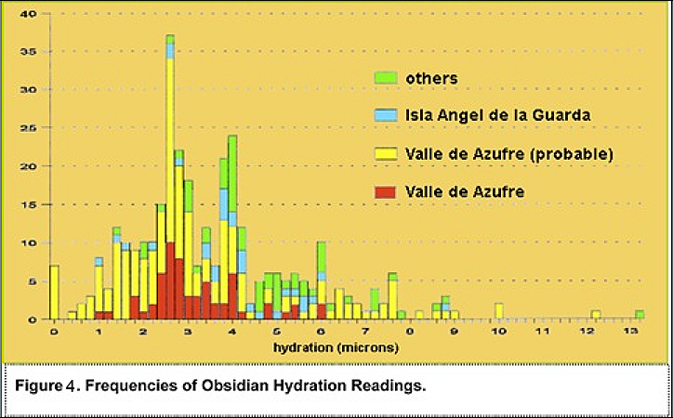

Obsidian begins to become hydrated on its surface or rind the moment it is flaked so that the thickness of this rind or calibration in microns is a *relative* measure of its calendrical age (Laylander 1987:435-436; Meighan 1978:9; Ritter 1979:120) (Figure 5), but there is no consensus on the proper methodology of calibration. When calibrated by four different methods the approximate dates of obsidian hydration are presented in Fig. 5 based on 339 readings (Figure 5).

SUMMARY

This specimen has a hydration rind of approximately 4 microns, which places it between ca. 500 B.C. and 1000 A.D. based on these four different hydration curves or at least 500 years before the protohistoric or European contact period. If this hydration date is a measure of the trading and intercommunity exchange activity of the prehistoric Cochimi in the Sierra San Francisco it may be associated with the time horizon of their diffusion of Grand Mural rock art style and its protocols within the Sierra San Francisco.

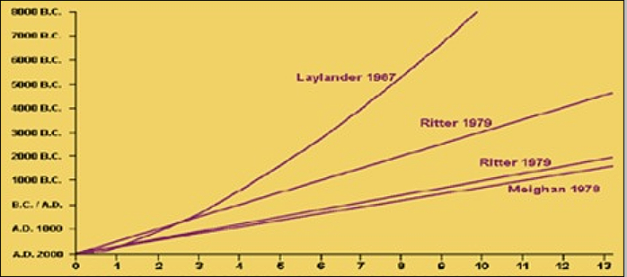

**Figure 5. Obsidian hydration curves according to 4 estimates.**

**References:**

Banks, Thomas Jeffrey  
1971 Geologic Obsidian Sources for Baja California. Pacific Coast Archaeological Society Quarterly 7(1):24-26.  
Bouey, Paul D.  
1984 Obsidian Studies and Their Implications for Prehistory. Pacific Coast Archaeological Society Quarterly 20(1):55-60.  
Carmean, Kelli  
1994 A Metric Study of Baja California Sur Projectile Points. Pacific Coast Archaeological Society Quarterly 30(1):52-75.  
Des Lauriers, Matthew R.  
2006 Isla Cedros. In The Prehistory of Baja California: Advances in the Archaeology of the Forgotten Peninsula, edited by Don Laylander and Jerry D. Moore, pp. 153-166. University Press of Florida, Gainesville.  
Douglas, Ronald D.  
1981 An Archaeological Reconnaissance in Arriba de Arroyo Matomi, Baja California Norte, Mexico. Pacific Coast Archaeological Society Quarterly 17(1):62-69.  
González-José, Rolando, Antonio González-Martín, Miguel Hernández, Héctor M. Pucciarelli, Marina Sardi, Alfonso Rosales, and Silvina van der Molen  
2003 Craniometric Evidence for Palaeoamerican Survival in Baja California. Nature 425:62-65.  
Gutiérrez, María de la Luz, and Justin R. Hyland  
2002 Arqueología de la Sierra de San Francisco: Dos décadas de investigación del fenómeno Gran Mural. Instituto Nacional de Antropología e Historia, Mexico City.  
Hughes, Richard E., and James A. Bennyhoff  
1986 Early Trade. In Great Basin, edited by Warren L. d’Azevedo, pp. 238-255. Handbook of North American Indians, vol. 11, William C. Sturtevant, general editor. Smithsonian Institution, Washington, D.C.  
Hughes, Richard E., and Delbert L. True  
1985 Perspectives on the Distribution of Obsidians in San Diego County, California. North American Archaeologist 6:325-339.  
Hyland, Justin R.  
1997 Image, Land, and Lineage: Hunter-Gatherer Archaeology in Central Baja California, Mexico. Unpublished Ph.D. dissertation, Department of Anthropology, University of California, Berkeley.  
2006 The Central Sierras. In The Prehistory of Baja California: Advances in the Archaeology of the Forgotten Peninsula, edited by Don Laylander and Jerry D. Moore, pp. 117-134. University Press of Florida, Gainesville.  
Hyland, Justin R., and María de la Luz Gutiérrez Martínez  
1995 Valle de Azufre: A New Obsidian Source in Central Baja California. Pacific Coast Archaeological Society Quarterly 31(1-2):103-111.  
Kelly, Robert L.  
1995 The Foraging Spectrum: Diversity in Hunter-Gatherer Lifeways. Smithsonian Institution Press, Washington, D.C.  
Laylander, Don  
1987 Sources and Strategies for the Prehistory of Baja California. Unpublished Master’s thesis, Department of Anthropology, San Diego State University.  
1997 The Linguistic Prehistory of Baja California. In Contributions to the Linguistic Prehistory of Central and Baja California, edited by Gary S. Breschini and Trudy Haversat, pp. 1-94. Coyote Press Archives of California Prehistory No. 44. Salinas, California.  
2002 Assessing the Magnitude of Hydration Chronology Error for Coso Obsidian in Western Inyo County. Proceedings of the Society for California Archaeology 15:61-65.  
2005 Research Issues in San Diego Archaeology. http://home.earthlink.net/~researchissues.  
Macko, Michael E., Jeffrey S. Couch, and Henry C. Koerper  
2005 Implications of Ritual Biface Caches from the Irvine Site. Journal of California and Great Basin Anthropology 25:93-107.  
Massey, William C.  
1949 Tribes and Languages of Baja California. Southwestern Journal of Anthropology 5:272-307.  
1961 The Cultural Distinction of Aboriginal Baja California. In Homenaje a Pablo Martínez del Río en el vigésimoquinto aniversario de la primera edición de “Los orígenes americanos,” pp. 411-422. Institutio Nacional de Antropología e Historia, Mexico City.  
McFarland, Sharon L.  
2000 Changes in Obsidian Exchange in Southern California. Unpublished Master’s thesis, Department of Anthropology, San Diego State University.  
  
Meighan, Clement W.  
1978 Analysis of Rock Art in Baja California. In Seven Rock Art Sites in Baja California, edited by Clement W. Meighan and V. L. Pontoni, pp. 1-18. Ballena Press Publications in North American Rock Art No. 2. Socorro, New Mexico.  
Mixco, Mauricio J.  
1978 Cochimí and Proto-Yuman: Lexical and Syntactic Evidence for a New Language Family in Lower California. University of Utah Anthropological Papers No. 101. Salt Lake City.  
1979 Northern Cochimí Dialectology and Proto-Yuman. Journal of California and Great Basin Anthropology Papers in Linguistics 1:39-64.  
2006 The Indigenous Languages. In The Prehistory of Baja California: Advances in the Archaeology of the Forgotten Peninsula, edited by Don Laylander and Jerry D. Moore, pp. 24-41. University Press of Florida, Gainesville.  
Moore, Jerry D.  
2001 Extensive Prehistoric Settlement Systems in Northern Baja California: Archaeological Data and Theoretical Implications from the San Quintín-El Rosario Region. Pacific Coast Archaeological Society Quarterly 37(4):29-51.  
  
Ritter, Eric W.  
1979 An Archaeological Study of South-Central Baja California, Mexico. Unpublished Ph.D. dissertation, Department of Anthropology, University of California, Davis.  
2001 Observations Regarding the Prehistoric Archaeology of Central Baja California. Pacific Coast Archaeological Society Quarterly 37(4):52-79.  
Ritter, Eric W., and Louis A. Payen  
1992 Archaeological Discoveries along Laguna Ojo de Liebre, Baja California, Mexico. In Essays on the Prehistory of Maritime California, edited by Terry L. Jones, pp. 251-266. Center for Archaeological Research at Davis Publication No. 10. University of California, Davis.  
Rivet, Paul  
1909 Recherches anthropologiques sur la Bass-Californie. Journal de la Société des Américanistes de Paris. 6:147-253.  
Rosales-López, Alfonso, and Harumi Fujita  
2000 La antigua California prehispánica: La vida costera en El Conchalito. Instituto Nacional de Antropología e Historia, Mexico City.  
Shackley, M. Steven  
1988 Sources of Archaeological Obsidian in the Southwest: An Archaeological, Petrological, and Geochemical Study. American Antiquity 53:752-772.  
1994 Análisis de energía dispersiva en fluorescencia de rayos X (EDXRF) de artefactos de obsidiana, de sitios arqueológicos en Bahía de los Angeles y materiales de una fuente de obsidiana en Isla Angel de la Guarda, Baja California. In Investigaciones de ecología social y cambios entre culturas prehistóricas en la región de Bahía de los Angeles, Baja California (1993), by Eric W. Ritter, pp. 172-184. Instituto Nacional de Antropología e Historia, Mexicali, Baja California.  
1995 Análisis de energía dispersiva de fluorescencia de rayos X (EDXRF) en artefactos de obsidiana de ocho sitios arqueológicos en Bahía de los Angeles, Baja California Norte: temporada de campo 1994. In Investigaciones de ecología social y cambios entre culturas prehistóricas en la región de Bahía de los Angeles, Baja California (1994), by Eric W. Ritter, pp. 197-208. Instituto Nacional de Antropología e Historia, Mexicali, Baja California.  
1997 Análisis de energía dispersiva de fluorescencia de rayos X (EDXRF) en artefactos de obsidiana y estándares de yacimiento de cinco sitios arqueológicos en Bahía de los Angeles, Baja California Norte: Temporada de campo 1995. In Investigaciones de ecología social y cambios entre culturas prehistóricas en la región de Bahía de los Angeles, Baja California (1995), by Eric W. Ritter, pp. 201-210. Instituto Nacional de Antropología e Historia, Mexicali, Baja California.  
1998a An Energy Dispersive X-ray Fluorescence (EDXRF) Analysis of Obsidian Artifacts from Archaeological Sites in the San Quintín-El Rosario Region, Baja California. Report on file, Department of Anthropology, California State University, Dominguez Hills.  
1998a Supplemental Report: An Energy Dispersive X-ray Fluorescence (EDXRF) Analysis of Obsidian Artifacts from Archaeological Sites in the San Quintín-El Rosario Region, Baja California. Report on file, Department of Anthropology, California State University, Dominguez Hills.  
1999 Análisis de energía dispersiva de fluorescencia de rayos X (EDXRF) de artifactos de obsidiana de sitios prehistóricos en Laguna Guerrero Negro, Baja California Norte. In Investigaciones arqueológicas en Laguna Guerrero Negro, Baja California (Fase I), by Eric W. Ritter, appendix 5. Instituto Nacional de Antropología e Historia, Mexico City.  
2002 Un análisis de fluorescencia de rayos X de longitud de onda dispersiva en artifactos procedentes de los sitios prehistóricos en Laguna Guerrero Negro y Laguna Manuela, Baja California. In Investigaciones arqueológicas en Laguna Guerrero Negro y Laguna Manuela, Baja California, México (Fase II), by Eric W. Ritter, appendix 1. Instituto Nacional de Antropología e Historia, Mexico City.  
2004a Source Provenience of Obsidian Artifacts from Laguna Manuela and La Angostura, Central Baja California. Berkeley Archaeological XRF Lab, University of California, Berkeley.  
2004b An Energy-Dispersive X-ray Fluorescence (EDXRF) Analysis of Obsidian Artifacts from Agua de Higuera, Camino San Borja, Valle de San Julian, and San Ignacito, Central Baja California. Berkeley Archaeological XRF Lab, University of California Berkeley.  
Shackley, M. Steven, Justin R. Hyland, and María de la Luz Gutiérrez Martínez  
1996 Mass Production and Procurement at Valle de Azufre: A Unique Archaeological Obsidian Source in Baja California Sur. American Antiquity 61:719-731.  
Tuohy, Donald Raymond  
1978 Culture History in the Comondu Region, Baja California, Mexico. Unpublished Master’s thesis, Department of Anthropology, University of Nevada, Las Vegas.  
Waechter, Sharon A., and Thomas M. Origer  
1993 A Discussion of Multiple Hydration Bands and Obsidian Scavenging at CA-COL-160, Mendocino National Forest. In There Grows a Green Tree: Papers in Honor of David A. Fredrickson, edited by Greg White, Pat Mikkelsen, William R. Hildebrandt, and Mark E. Basgall, pp. 277-284. Center for Archaeological Research at Davis Publications No. 11. University of California, Davis.